Application of linear programming for profit maximization

Domagoj Bekavac  
Zagreb School of Economics and Management   
 Business Mathematics and Economics  
BME Capstone 2020/21  
Zagreb, Croatia  
Dbekavac@student.zsem.hr

*Abstract* — The goal of this project was to perform simplex linear programming techniques on an actual data and to explain all terms which are necessary. It introduces us to diverse products, raw materials and how companies use them in order to maximize their profit. Later on, I described methods for calculating LP problems and 3 works related to my project in order to get better insights. The data was collected form bakery Horvat located in Veliko Trgovišće.

Keywords — Profit, objective function, price, cost, quantity, constraints, products, raw materials, variables, maximization.

# Introduction

## Introductory description of the problem

Goal of every company is to make profit and that is why it is especially important in business to develop strategic management plans, especially for large industries.

When a problem involves a variety of resource constraints, then it is best to use **linear programming** in order to derive the best solution (maximum profit, minimal loss, best resource allocation, etc.).

Real life problems are translated into mathematical models to better conceptualize linear inequalities and their constraints.

## Problem explanation

In my thesis I will maximize the objective function of a company by using linear programming algorithms (finding maximum profit of a company).

To do that I needed to find dataset with all products, prices, costs, and constraints for raw materials.

# Aim of problem research

This problem is solved by an **operational research** method, which is an analytical method of problem-solving and decision-making useful in management of organizations.

Problems are broken down into basic components and then solved by mathematical analysis in predefined steps[2].

Steps:

1. Identifying a problem that needs to be solved.
2. Constructing a model around the problem that resembles the real world and variables.
3. Using the model to derive solutions to the problem.
4. Testing each solution on the model and analyzing its success.
5. Implementing the solution to the actual problem.

Aim is to achieve the best performance (maximize the objective function of a company) with given variables and constraints using mathematical optimization [2].

# Review of previous research

## Existing methods by which the problem was solved:

### Graphical method

First method for solving linear programming problem is a **graphical method** which allows solving simple problems intuitively and visually.

Big disadvantage of this method is that it is limited to only 2 or 3 problem decision variables and it is not possible to illustrate more than 3D. Begin by drawing a picture and introducing variables, then find a function of one variable to describe the quantity that is to be minimized or maximized (objective function). Look for critical points to locate local extrema.

Examples of graphical methods: <https://courses.lumenlearning.com/sanjacinto-finitemath1/chapter/reading-meeting-demands-with-linear-programming/>

### Simplex method

To handle linear programming problems that contain more than 2 variables, mathematicians developed what is now known as the **simplex method**.

It is a more efficient method and also more complex to use. It goes through corner points until it has located the one that maximizes the objective function.

Different examples of linear programming problems using simplex method:

<https://courses.lumenlearning.com/sanjacinto-finitemath1/chapter/reading-solving-standard-maximization-problems-using-the-simplex-method/>

I would like to mention for my example one particular optimization problem called the **assignment problem**

It arises because available resources have varying degrees of efficiency for performing different activities.

The aim is to optimize the given objective function by allocating the assignments.

Hungarian method:

We need to know only the cost of making all the possible assignments (the cost matrix). The optimum solution for the problem will be achieved by reducing cost matrix.

Alternate method:

The minimum cost entry in each row of the cost matrix is used for feasible assignment (each row has a unique minimum cost entry) [3].

## Related work

### **“On the Use of Linear Programming Model Approach in Profit Optimization of a Product Mix Company**” by Garba M. K., Banjoko A. W., Yahya W. B. and Gatta N. F. Department of Statistics, University of Ilorin, Nigeria.

This research is an excellent example of the usage of the simplex method in linear programming problem. Data was extracted from the record unit for an item blend fabrication industry, Fortunate Bakery, Ilorin, Nigeria and they used this data to maximize profit using simplex method.

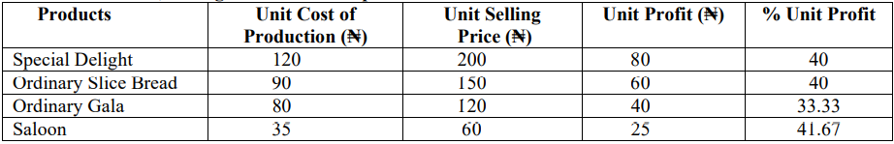

Fig 1. 4 products, their costs, prices and profits.

In this table we can see a list of products and the profits they give. But products need raw materials for their production, so they found information on that also and presented it in another table.

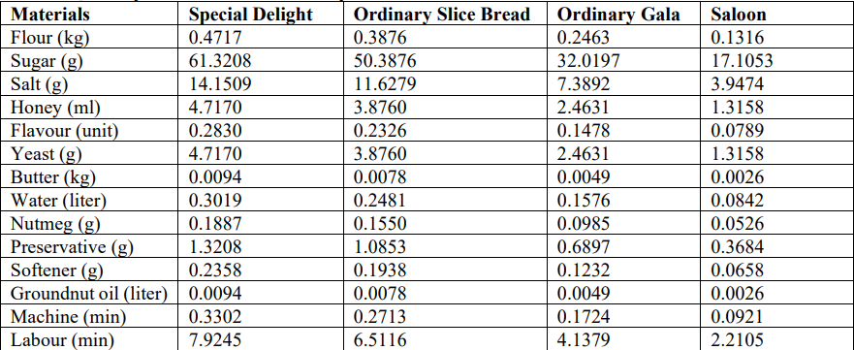

Fig 2. Usage of raw materials in a production process.

Most important part of the research are of course constraints for raw materials, meaning that every material has maximum quantity available in stock and is presented also in another table.

With all this information they started with their project.

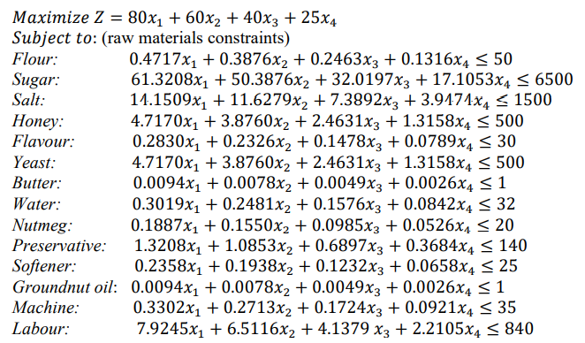

Fig 3. Objective function and constraints, standard form.

Also, they set nonnegativity constraints (x1,x2,x3,x4 >= 0) and added slack variables (unused amount) to the LHS of the equations they changed inequality signs to equality.

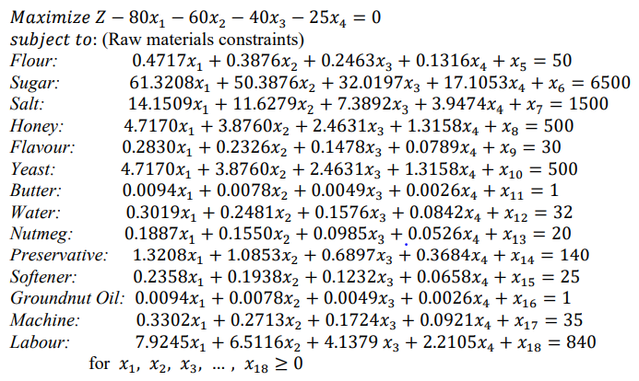

Fig 4. Objective function and constraints.

This form is crucial for solving LP problem with the simplex method because the next step is to construct the matrix.

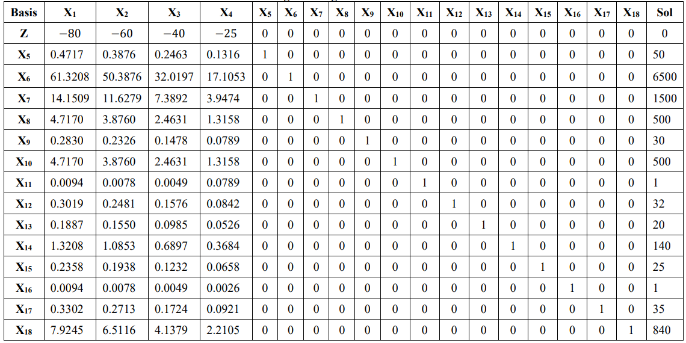  
Fig 5. Linear programming matrix.

In the last table we can see all products (x1-4) and also 14 slack variables (x5-18) representing unused raw materials in the production process.

In the first row (or it can be in the last row, it does not matter) we can see the objective function that needs to be maximized (profit) or minimized (cost), in their case it is about profit maximization represented by variable Z.

I will not go into details with this project (I will explain everything in mine), but it must be said that to obtain optimal solution by this method, we need to find pivot variable (intersection of the pivot row and pivot column) that we use to increase the objective function.

We repeat the process (iterations) until there are no negative values in the first row (the function is maximized, final iteration).

They maximized solution after fifth iteration, the daily estimated value of the objective function was obtained to be 9498.4802 (approximately 9,500) and the daily contributions of each of the four decision variables x1, x2, x3, x4 into the objective function are 0, 0, 0, and 379.94 (approximately 380) [4].

### **“APPLICATION OF LINEAR PROGRAMMING FOR PROFIT MAXIMIZATION OF A PHARMA COMPANY”** by Amit Kumar Jain, Hemlata Saxena, Ramakant Bhardwaj, G. V.V. Jagannadha Rao,Ch. Siddharth Nanda (India).

The goal of this paper was to find the maximum profit and to minimize the transportation cost of the company Mascot Herbals PVT.LTD. and Ashwini Herbal Pharmacy.

As we saw in research above, they used the same method for solving, making it an excellent example for my proposal.

They made a list of products and the ingredients used for them (type A and type B), of course they do not have infinite of them, rather they are limited.

With introducing slack variables, they constructed the problem matrix and got the optimal solution (Z=11760, with type A=400 and type B=20).

More interesting part of this research is a part where they calculated minimal cost.

I always talked about profit maximization, but cost minimization is also especially important for successful business, and they calculated using given information (factories and markets) minimal transportation cost.

The model indicates that the optimum result is derived from the data collected so the minimum transportation cost of Company is 19200 and the number of syrup packet transport from factory P to customer C2 is 70, from factory P to customer C3 is 50, from factory Q to customer C1 is 60, from factory Q to customer C2 is 20 and none of the packet transport from factory P to customer C1 and from factory Q to customer C3 [5].

### **“OPTIMIZING PROFIT WITH THE LINEAR PROGRAMMING MODEL ON SMALL SCALE BUSINESS IN TARABA STATE”** by Danjuma, Habiba Department of Statistics, Federal Polytechnic Bali, Bali, Taraba State.

This paper examined the profit making of small and medium scale (SMEs) business in Jalingo, capital city of Taraba state with available resources.

I will not go into details with this problem, and I will say only that he in his research used materials and profits of the SMEs operators and with that information he arrived at optimal resource allocation(maximum profit) [6].

# Problem

Problem solution in short:

Collecting of data.

Examining the data (understanding variables, constraints, and objective function).

Writing equations (inequalities).

Constructing a table (matrix).

Finding optimal solution using simplex method (iterations until I get maximum profit achievable with given constraints).

## Motivation and goals

During my study program at ZSEM I always wanted to do project based on linear programming. It was remarkably interesting to me, challenging, and helpful, so it was not difficult for me to choose the topic of Capstone project.

I want to use all methods for solving linear programming problems that I learned and obtain solution that I hope will be helpful not only for me, but for the bakery as well, even though the solution works only in ideal scenario.

Many industries use linear programming as a standard tool, e.g., to allocate a finite set of resources in an optimal way [7], and I also studied numerous research papers using various methods for obtaining best possible solution.

In short, the goal of my project is to find an optimal solution for specific company, in my case bakery Horvat and guide quantitative decisions in business planning.

## Dataset

I had problems finding useful dataset with all components. Every data that I found is either incomplete, solved already or too simple for a project (for example datasets that we used in a Linear Programming course with our professor).

To use a simplex linear programming method on specific problem, you must have information on all data that is necessary in the equation.

In the case of profit maximization, one must have info on products that are being sold in the market, their prices, costs for making primary goods, list of raw materials, their prices in the market and constraints (maximum value available on daily, weekly, monthly or yearly basis).

I decided to ask my friend who works in bakery located in Veliko Trgovišće to let me use their data for my project.

In my opinion, there was no better way of accumulating data, because bakeries are the simplest example for someone who is doing a project for the first time and wants to express themselves in their work.

### Data on products

|  |  |  |  |  |
| --- | --- | --- | --- | --- |
| X | Products | Price (Kn) | Cost (Kn) | Profit (Kn) |
| X1 | Bread | 6 | 1.29 | 4.71 |
| X2 | Small bagel | 2.5 | 0.11 | 2.39 |
| X3 | Large bagel | 3 | 0.23 | 2.77 |
| X4 | Chocolate donut | 4 | 1.61 | 2.39 |
| X5 | Chocolate croissant | 4 | 2.01 | 1.99 |
| X6 | Pizza ham and cheese | 8 | 2.65 | 5.35 |
| X7 | Sandwich ham and cheese | 5 | 1.56 | 3.44 |
| X8 | Hot dog with cheese | 7 | 1.51 | 5.49 |

Fig 6. 8 products, their costs, prices and profits.

Here you can see data on 8 of their products: bread, small and large bagel, chocolate croissant and donut, pizza and sandwich with ham and cheese and hot dog with cheese.

First column contains their respective prices (in Kn) which were listed on product offers.

Values that were missing and I had to compute them are those in second column, costs for their production.

I calculated this by looking at the weight (in kg) of each product and with the help of raw materials used in a production process.

Every product has unique recipe for their making containing various raw materials that they order on monthly basis.

I got info on their monthly orders, precisely how much of each resource they demand and their respective prices, so I took that data to calculate cost of each good.

In the table below you can see all products and their weights.

|  |  |  |  |
| --- | --- | --- | --- |
|  |  | Price(Kn) | weight(kg) |
| X1 | Bread | 6 | 0.7 |
| X2 | Small bagel | 2.5 | 0.06 |
| X3 | Large bagel | 3 | 0.12 |
| X4 | Chocolate donut | 4 | 0.12 |
| X5 | Chocolate croissant | 4 | 0.14 |
| X6 | Pizza (ham and cheese) | 8 | 0.25 |
| X7 | Ham and cheese sandwich | 5 | 0.17 |
| X8 | Hot dog with cheese | 7 | 0.2 |

Fig 7. 8 products, their prices and weights.

### Data on raw materials



Fig 8. Usage of raw materials in a production process.

Table above contains all raw materials and how much of each is used in a production of final goods.

It is very detailed and accumulated so it is hard to see an actual data, but I will write below the numbers connected with flour for my example.

Flour (in kg): 0.5 (bread), 0.042 (small bagel), 0.084 (large bagel), 0.055 (chocolate donut), 0.058 (chocolate croissant), 0.1 (pizza with ham and cheese), 0.084 (sandwich with ham and cheese), 0.084 (hot dog with cheese)

This numbers reveal us that in production of bread for example, you need 500g of flour. Using all other materials for all other products I calculated their monthly costs (in Kn) per 1 kg/1 l/1 peace of raw material.



Fig 9. Raw materials, their price per kg/l/unit and quantity available.

As you can see, they do not pay anything for water, because they use it form home, so the bakery does not bear any costs in using the water.

Numbers in the 3rd column represent constraints or maximum amount available of each ingredient.

I collected them form their official order papers (ordered quantity and respective price).

As it was different every month, I decided to calculate an average monthly quantity demanded, prices as well.

With all the data form above it is necessary to calculate profits they obtain from selling each good (visible in 1st table), which are then used in composing an objective function.

It was challenging for me to calculate all the missing values in my data, but I succeeded and was ready to continue with my project.

## Methods

There are many methods for obtaining the best possible solution. As I mentioned before mathematicians developed graphical and simplex method for solving problems.

Another way to obtain a solution is by using Solver (Excel) which takes problem descriptions in some sort of generic form and calculates their solution, also it is feasible to come to a conclusion by coding using different programming languages.

For my problem I focused on obtaining a solution in 3 ways, finding, and explaining pivot values and iterating applying elementary row operations in the matrix, by using Excel analytical tool Solver and also using by using Python.

Since the data is too big, and I have more than 2 variables, I cannot use graphical method for obtaining solution.

### Elementary row operations in Matrix

This is the first method by which one can arrive to optimal solution.

It is overly complex to do it when there is a lot of data in the table, and this was the case in my project.

In section Related work I mentioned and explained how they used this method to come to a solution.

First step is to construct the **matrix** containing all data necessary for further work (products, raw materials, objective function value and variables value).

Remaining slack variables are entered on the left-hand side of the constraint equations.

Matrix at the beginning has all info about the quantity of raw materials used in a production, maximum profit value (at the start is 0), and also possible product quantities which are the missing values, and we must obtain them.



Fig 10. Example of elementary row operations.

Here you can see one small example of simplex method matrix.

X(1-n) represent final goods in a production process and how much quantity of each raw material they need.

B column or base column represents **slack variables** which we need to replace with an actual products.

Cb column contains values on profit, that is, how much company earns per one sold unit of each of their goods.

P column symbolizes constraints that have to be satisfied in order to run good business.

Cell colored in yellow represents optimal value or in this case, maximum profit achievable given all satisfied conditions.

Goal of this method is to replace slack variables with actual final goods and see which allocation of products is most profitable for the firm in question. To do so it is necessary to introduce a **pivot element**.

It represents an entry which is located at the intersection of entering column and departing row.

Entering column: where value x in x(1-n) has the most negative value.

Departing row: where ratio (r, column Q) has smallest value.

r = p/x (x form entering column).

When we find pivot element, then it is time to perform elementary row operations until there are no negative values in the first row (iterating).

We obtained final solution.

**My solution**:

By using <https://linprog.com/> matrix calculator, after 9 iterations I came to a conclusion.

In order for bakery to maximize their profits, they need to produce 4832 units of bread, 18800 small bagel units, 1600 slices of pizza and 1000 hot dogs.

Other products have 0 by their name, meaning that they are not profitable for the industry and it is best not to produce them.

**Maximum profit amounts 81740.72 Kn monthly.**

Of course, that in real life it is not possible to operate in that way since only in ideal case people are indifferent between all their products (exchanging chocolate croissant with bread for example).

### Solver

Other method that I used is a part of Excel analytics and is called **Solver.**

It is a simpler way for calculating maximum profit of a company.

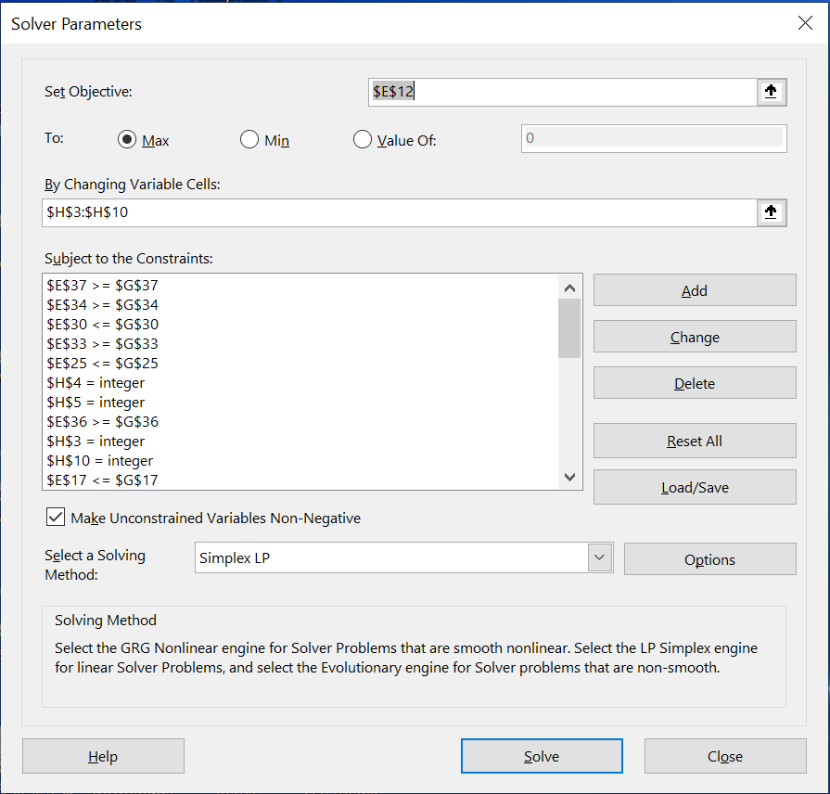

Fig 11. Solver

All I did was to select an objective function cell, changing variable cells representing optimal product quantities that we have to obtain, and set constraints.

Solver goes through all iterations which is much faster way than the one before and it maximizes an objective function.

I got the same numbers as before, meaning that this solution is indeed optimal, and it cannot go higher.

### Jupyter notebook (Python)

Last method that I used in my project is done by coding in programming language Python.

This approach was the most challenging one because I have never done linear programing problems by Jupyter Notebook but using my knowledge form Introduction to Python course I managed to find a code.

The solution was slightly different by using this method because variables are not set to be integers.

# Conclusion

Evaluation of the project.

When I collected data on products, prices, etc. I also got an information about their average monthly sales and profit.

Given that information I can measure the success of my project even if it is for ideal case and is not possible in real life.

Estimated monthly profit: around 65000 kn.

Maximum profit achievable through linear programming model: around 82000 kn.

It is a clear indicator that my project was successful.

I managed to connect official data and missing values that I obtained through multiple calculations to arrive to optimal and satisfactory solution using 3 effective methods.

It was for me personally challenging project, but also interesting and I hope that I will continue with it in future and use these methods on broader datasets of other companies.

In the end I would like to thank my professors Andrija and Tomislav for helping me with all problems regarding this project and for expanding my knowledge.

# Reference list

[1] OR, Sarah Lewis, Technical writer.

[2] <https://whatis.techtarget.com/definition/operations-research-OR>.

[3] <https://core.ac.uk/download/pdf/249335256.pdf>.

[4] <https://www.iuiu.ac.ug/journaladmin/iumj/ArticleFiles/79853.pdf>,

“On the Use of Linear Programming Model Approach in Profit Optimization of a Product Mix Company” Garba M. K., Banjoko A. W., Yahya W. B. and Gatta N. F. Department of Statistics, University of Ilorin, Nigeria, IUMJ, vol. 7 (2), 2020.

[5] <http://www.jcreview.com/fulltext/197-1592807730.pdf>,

“APPLICATION OF LINEAR PROGRAMMING FOR PROFIT MAXIMIZATION OF A PHARMA COMPANY” Amit Kumar Jain, Hemlata Saxena, Ramakant Bhardwaj, G. V.V. Jagannadha Rao,Ch. Siddharth Nanda, India, Vol 7, Issue 12, 2020.

[6] <https://www.bakundijournal.com/-/uploads/habiba%20full.pdf>,

“OPTIMIZING PROFIT WITH THE LINEAR PROGRAMMING MODEL ON SMALL SCALE BUSINESS IN TARABA STATE” Danjuma, Habiba Department of Statistics, Federal Polytechnic Bali, Bali, Taraba State.

[7] [https://cs.nyu.edu/~overton/g22 lp/encyc/article web.html](https://cs.nyu.edu/~overton/g22%20lp/encyc/article%20web.html),

“Linear Programming”, **Michael L. Overton**, **Draft for Encyclopedia**

**Americana, December 20, 1997.**